Intelligent Agent

🔹 What is an Agent?
- An agent is anything that perceives its environment and takes actions to achieve a goal.
- Examples of agents:
  - Humans
  - Machines
  - Robots
  - Computer Programs
- 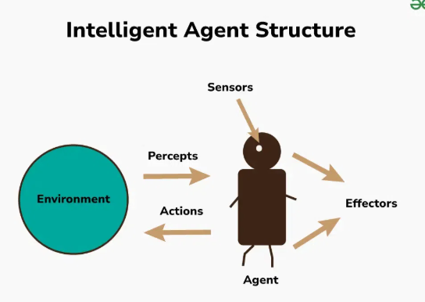

🔹 Operations of an Agent
- Sensing / Perception
  - Agents perceive the environment using sensors.
  - For humans: eyes, ears, skin, nose, tongue.
  - Two types of perception:
    - Current: what is being sensed now.
    - Historical: based on memory or past experiences.
- Decision Making (Agent Program)
  - Makes decisions based on perceptions (current + historical).
  - Compares present input with past experience.
  - Maps situations to decisions using logic or learned behavior.
- Acting / Performing Actions
  - Executes actions using effectors (outputs).
  - For humans: hands, legs, mouth.
  - For machines: motors, speakers, mechanical arms.

🔹 Simple Human Example:
- You step outside → sense dark clouds → decide to carry an umbrella → perform action (pick umbrella) → go back to environment.
- Agent cycle: Perception → Decision → Action

🔹 Goals of an Agent
- High Performance
- Optimized Results
- Rational Actions (right or correct decision)

🔹 Real-World Examples of Agents
- Robots like Sofia, KURI (Sony), Boston Dynamics' robot
- These robots mimic human-like sensing, decision-making, and actions.

🔹 PEAS Model (Used to Design Agents)
PEAS Component | Meaning
P | Performance measure (e.g., safety, time, comfort for self-driving car)
E | Environment (e.g., road, traffic, pedestrians)
A | Actuators / Actions (e.g., steering, braking, acceleration)
S | Sensors (e.g., cameras, radar, wipers, rain sensors)
- PEAS helps in designing and evaluating an intelligent agent.

🔹 Types of Agents
- Simple Reflex Agents – Act only on current perception.
- Model-Based Reflex Agents – Use history/memory of environment.
- Goal-Based Agents – Take actions based on achieving specific goals.
- Utility-Based Agents – Optimize based on utility (quality of outcome).
- Learning Agents – Improve their behavior over time from experience.
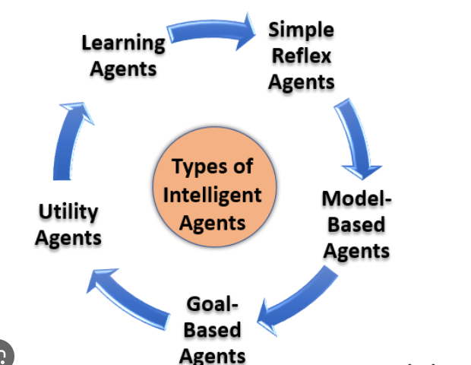
Types of Agents
1. Simple Reflex Agents
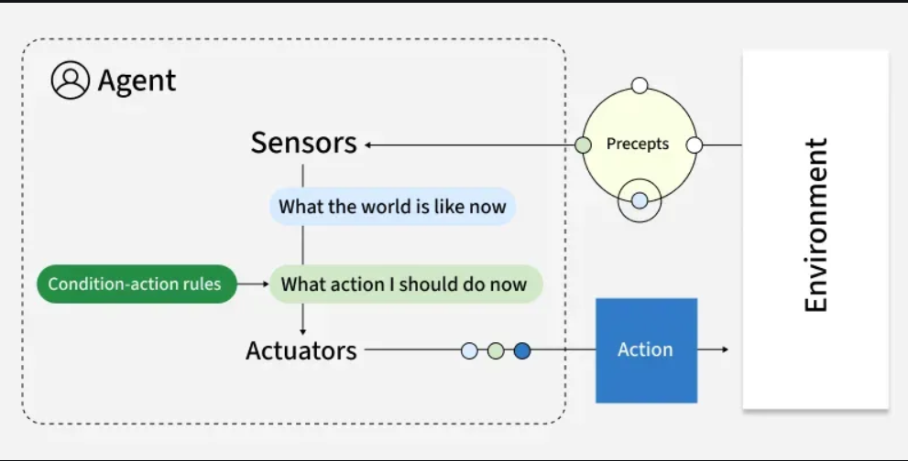
Simple Reflex Agent Working
Simple reflex agents act based solely on current perceptions using condition-action rules. These agents respond directly to stimuli without considering past experiences or potential future states. They operate on basic "if-then" logic: if a specific condition is detected, execute a corresponding action.
Key Features:
- No memory of past states
- No model of how the world works
- Purely reactive behavior
- Function best in fully observable environments
For Example, Traffic light control systems that change signals based on fixed timing.
2. Model-Based Reflex Agents
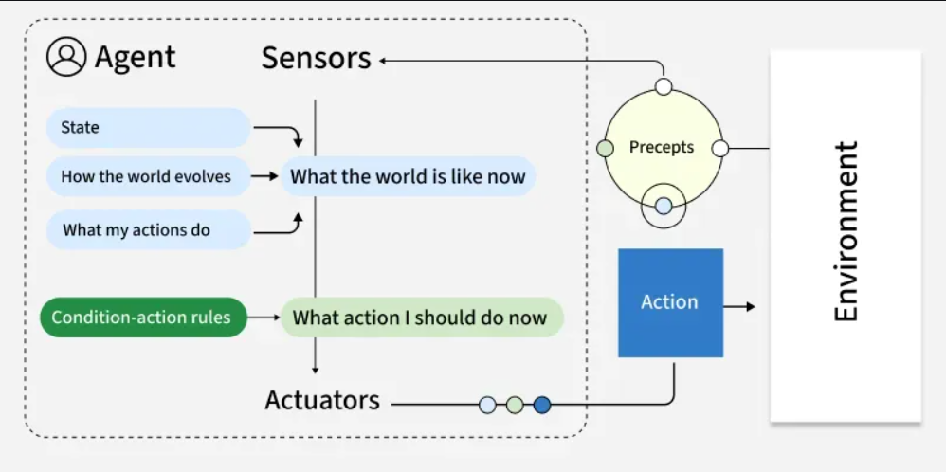
Model-Based Reflex Agent Working
Model-based reflex agents maintain an internal representation of the world, allowing them to track aspects of the environment they cannot directly observe. This internal model helps them make more informed decisions by considering how the world evolves and how their actions affect it.
Key Features:
- Track the world's state over time
- Infer unobserved aspects of current states
- Function effectively in partially observable environments
- Still primarily reactive, but with contextual awareness
For example, Robot vacuum cleaners that map rooms and tracks cleaned areas.
3. Goal-Based Agents
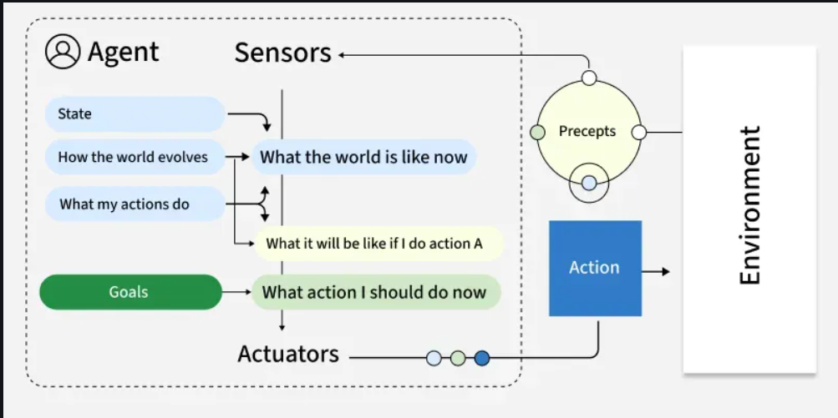

Goal-Based Agents Working
Goal-based agents plan their actions with a specific objective in mind. Unlike reflex agents that respond to immediate stimuli, goal-based agents evaluate how different action sequences might lead toward their defined goal, selecting the path that appears most promising.
Key Features:
- Employ search and planning mechanisms
- Evaluate actions based on their contribution toward goal achievement
- Consider future states and outcomes
- May explore multiple possible routes to a goal
For example, Logistics routing agents that find optimal delivery routes based on factors like distance and time. They continually adjust to reach the most efficient route.
- Utility-Based Agents
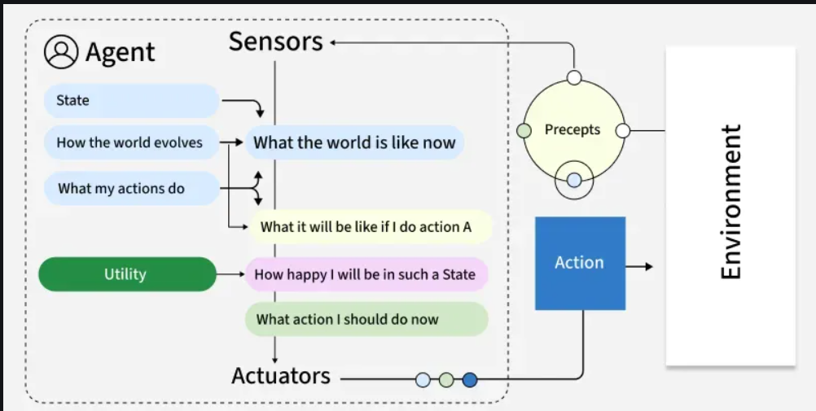
Utility-Based Agent Working
Utility-based agents extend goal-based thinking by evaluating actions based on how well they maximize a utility function—essentially a measure of "happiness" or "satisfaction." This approach allows them to make nuanced trade-offs between competing goals or uncertain outcomes.
Key Features:
- Balance multiple, sometimes conflicting objectives
- Handle probabilistic and uncertain environments
- Evaluate actions based on expected utility
- Make rational decisions under constraints
For example, Financial portfolio management agents that evaluate investments based on factors like risk, return and diversification operate by choosing options that provide the most value.
- Learning Agents
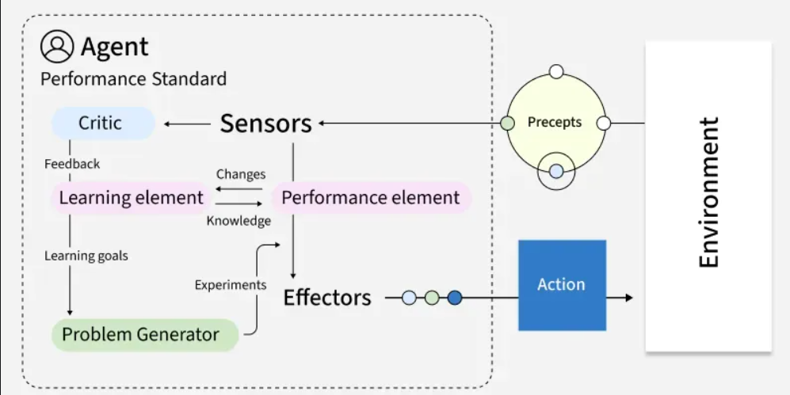
Learning Agent Working
Learning agents improve their performance over time based on experience. They modify their behavior by observing the consequences of their actions, adjusting their internal models and decision-making approaches to achieve better outcomes in future interactions.
Key Features:
- Adapt to changing environments
- Improve performance with experience
- Contain both a performance element and a learning element
- Generate new knowledge rather than simply applying existing rules
For example, Customer service chatbots can improve response accuracy over time by learning from previous interactions and adapting to user needs.
- Multi-Agent Systems (MAS)
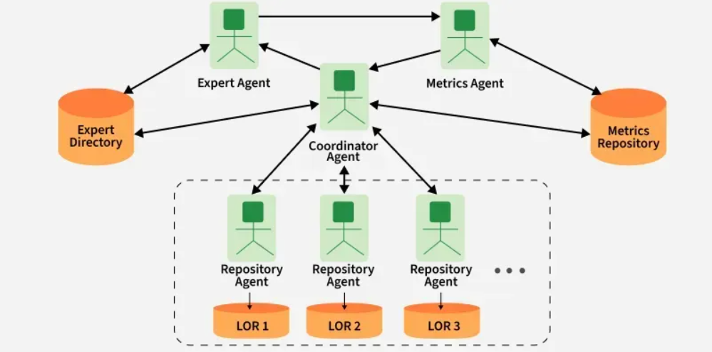
Multi-Agent System Working
Multi-agent systems consist of multiple autonomous agents that interact with each other within an environment. These agents may cooperate toward common goals, compete for resources or exhibit a mix of cooperative and competitive behaviors. Types of multi-agent systems:
- Cooperative MAS: Agents work together toward shared objectives.
- Competitive MAS: Agents pursue individual goals that may conflict.
- Mixed MAS: Agents cooperate in some scenarios and compete in others.
Key Features:
- Agents act independently and control their own state.
- Agents align, collaborate or compete to reach goals.
- The system remains resilient if individual agents fail.
- Decisions are distributed; there’s no single controller.
For example, a warehouse robot might use:
- Model-based reflexes for navigation
- Goal-based planning for task sequencing
- Utility-based decision-making for prioritizing tasks
- Learning capabilities for route optimization
- Hierarchical agents
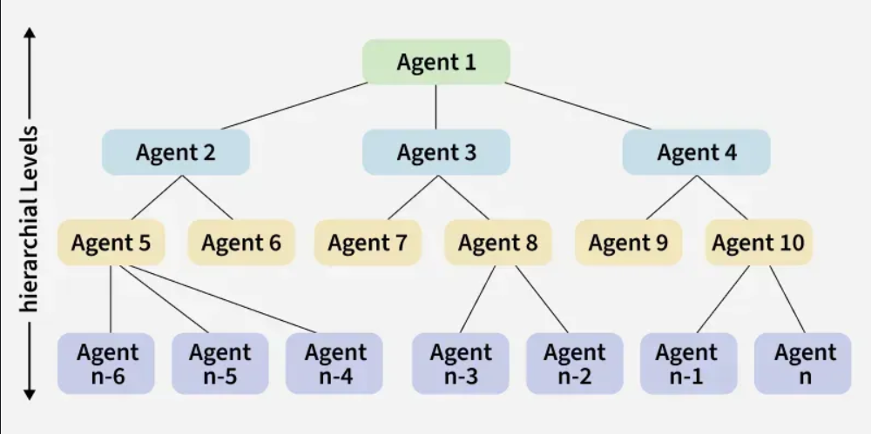
Hierarchical agents Working
Hierarchical agents organize decision-making across multiple levels, with high-level agents making strategic decisions and delegating specific tasks to lower-level agents. This structure mirrors many human organizations and allows for managing problems at appropriate levels of abstraction.
Key Features:
- Division of responsibilities across multiple levels
- Abstract decision-making at higher levels
- Detailed execution at lower levels
- Simplified information flow (higher levels receive summarized data)
For example, Drone delivery systems in which fleet management is done at top level and individual navigation at lower level.
Use Cases of AI Agents
Agents are used in a wide range of applications in artificial intelligence, including:
- Robotics: Agents can be used to control robots and automate tasks in manufacturing, transportation and other industries.
- Smart homes and buildings: They can be used to control heating, lighting and other systems in smart homes and buildings, optimizing energy use and improving comfort.
- Healthcare: They can be used to monitor patients, provide personalized treatment plans and optimize healthcare resource allocation.
- Finance: They can be used for automated trading, fraud detection and risk management in the financial industry.
- Games: They can be used to create intelligent opponents in games and simulations, providing a more challenging and realistic experience for players.
Benefits of AI Agents
- Fast and efficient operations.
- Adapt and learn from experience.
- Scalable for large or complex problems.
- Operate autonomously with minimal human input.
- Consistent, reliable task performance.
Limitations:
- Struggle with complex or unpredictable environments.
- High computational needs for learning and planning.
- Communication issues in multi-agent setups.
- Risk of bias or unintended actions.
- Challenges in designing clear goals and utility functions.

